|  |  |
| --- | --- |
| **Date** | 3 August 2025 |
| **Team ID** | LTVIP2025TMID30830 |
| **Project name** | Lease management |
| **Maximum Marks** |  |

**Problem Statement:**

**1.Current Statement:**

Traditional lease management in property firms is often handled using manual methods such as spreadsheets, emails, and fragmented tools. This leads to:

* Missed deadlines for lease renewals and rent payments
* Data entry errors and duplicate assignments
* Lack of workflow automation and approval control
* Poor communication with tenants
* No real-time visibility into lease performance

**2.Issue or challenge:**

During the development of the Lease Management System, several challenges were encountered across both the technical and functional layers. One of the key issues was ensuring **data integrity across related objects** like Tenant, Property, Lease, and Payment. This required carefully configuring **master-detail and lookup relationships** and implementing **Apex triggers** to prevent multiple tenants from being assigned to the same property. Another significant challenge was the creation of **complex validation rules** to enforce business logic, such as verifying that lease end dates occur after start dates and ensuring that all mandatory fields were correctly filled. Automating communication without user intervention also proved to be difficult, particularly when developing **scheduled Apex classes** to send timely rent reminders and dynamically populate email templates with tenant-specific information

**1. Data Integrity Across Related Objects**

* Ensuring correct relationships between **Tenant**, **Property**, and **Lease** objects.
* Preventing multiple tenants from being assigned to the same property using **Apex triggers**.

**2. Validating Complex Business Rules**

* Implementing custom validation logic such as:
  + Lease end date must be after the start date.
  + Required fields must be correctly filled.

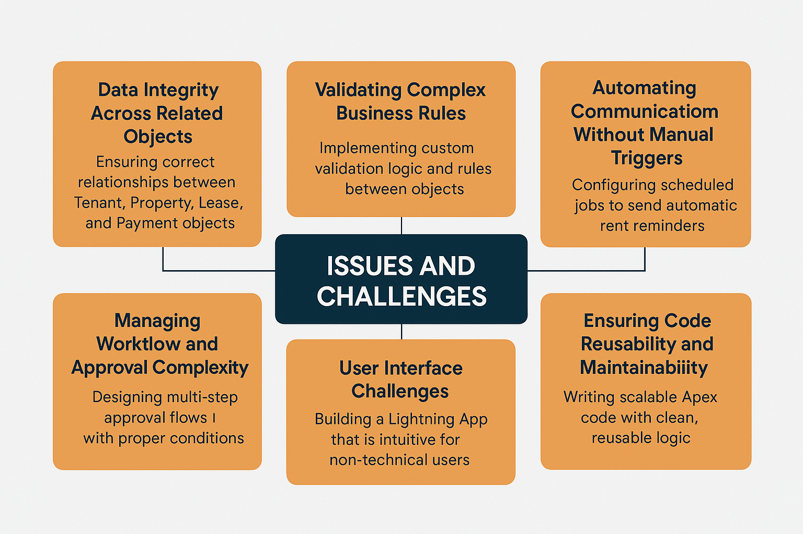

**IMPACT: Step 1: Identify Key Problems**

* Manual lease tracking using spreadsheets and emails
* Frequent data errors and duplication
* Missed rent due dates and lease expirations
* Delays in approval and communication processes
* Lack of real-time reporting or centralized control

🔹 Step 2: **Analyze Business Impact**

* Increased administrative burden on staff
* Reduced tenant satisfaction
* Financial loss due to late or missed payments
* Poor decision-making due to lack of visibility
* Risk of non-compliance with lease terms

🔹 Step 3: **Implement Salesforce-Based Solution**

* Created custom objects: Property, Tenant, Lease, Payment
* Enforced validation rules and approval workflows
* Built automation using Apex triggers and scheduled jobs
* Integrated email templates for automated communication
* Developed dashboards for real-time insights

🔹 Step 4**: Immediate Positive Impact**

* ✅ Centralized and accurate data
* ✅ Reduced manual work
* ✅ Faster lease processing and approvals
* ✅ Automated rent reminders and follow-ups
* ✅ Clear, consistent communication with tenants

🔹 Step 5**: Long-Term Impact**

* 📊 Improved decision-making through dashboards
* 🔁 Scalable architecture for future growth
* 💼 Enhanced operational control and accountability
* 📱 Ready for integration with mobile access and tenant portals
* 🧠 Foundation set for AI-driven analytics and automation

Top of Form

**3.GOAL:**

The primary goal of the Lease Management Project is to develop a centralized, automated, and user-friendly system using Salesforce that simplifies and streamlines the end-to-end lease management process. This includes managing property records, tenant information, lease agreements, and rent payments—while enforcing business rules, improving data accuracy, and automating communication.

Bottom of Form

**Key Highlights:**

* **Custom Salesforce App**: Built using Lightning App, with custom objects like Property, Tenant, Lease, and Payment.
* **Automation**: Enabled through Apex triggers, validation rules, approval processes, and scheduled Apex jobs.
* **Communication**: Integrated with predefined email templates for rent reminders, approvals, and rejections.
* **Performance**: Tested and validated for speed and reliability (object load <1 sec, trigger execution ~0.5 sec).
* **User Roles**: Designed for Salesforce Admins, Developers, Property Managers, and future tenant access.

**🔍 Challenges Addressed:**

* Enforced data integrity between related objects.
* Automated complex business rules and workflows.
* Improved UI/UX with Lightning components.
* Designed scalable and reusable backend logic.

**🌐 Future Scope:**

* Integration with payment gateways (e.g., Razorpay, Stripe).
* Tenant self-service portals.
* Mobile app access.
* Advanced analytics and AI-powered lease forecasting.

**🏁 Conclusion:**

The system successfully delivers a structured, automated, and scalable lease management platform. It significantly enhances day-to-day leasing operations and lays the foundation for future digital transformation in property management.